**Train Ticket Reservation System**

-DATABASE MANAGEMENT SYSTEMS PROJECT-

Group Members-

1. AS2021403 - D.P.G.A.H. Kulathilaka ………………………..
2. AS2021367 - T.G.D.S. Chathuranga .………………………..
3. AS2021573 - M.A.S.E.R. Wijerathna ………………………..
4. AS2021457 - R.M.D.D. Malinda ………………………..
5. AS2021517 - P.T.S. Karunarathna ………………………..
6. AS2021535 - H.R.S.U. Ranasinghe ………………………..
7. AS2021637 - M.A. Sathsarani ………………………..
8. AS2021359 - G.P.G. Pasqual ………………………..

CONTENTS

* Need OF a Solution
* Exploring Relationships
* Building Diagrams
* Assembling Ideas to a Reality
* Testing Phase
* Contributions

NEED of A SOLUTION

In today's fast-paced world, efficient and user-friendly train travel booking systems are crucial for both passengers and train operators. Traditional booking methods can be time-consuming, inconvenient, and lack real-time information. This proposal outlines the design and implementation of a modern train ticket booking system leveraging a robust database management system (DBMS) to address these challenges and create a seamless travel experience.

# **PROBLEMS CURRENTLY FACING**

1. **Inefficient booking process**: Long queues at counters, and outdated technology lead to frustration and delays for passengers.
2. **Lack of real-time information**: Inaccurate or delayed schedule updates, limited seat availability information, and minimal train progress updates hinder informed travel decisions.
3. **Inflexible booking options**: Difficulty managing bookings, limited cancellation policies, and limited booking channels create inconvenience and inflexibility.
4. **Poor communication**: Delayed or unavailable information about emergencies, schedule changes, and disruptions significantly impact passenger journeys.

# **HOW AN OPTIMIZED DATABASE HELPS**

1. **Streamline booking process**: Implement online and mobile booking options, enable self-service ticket management, and provide real-time seat availability.
2. **Enhance data management**: Create a centralized database for train schedules, fares, user information, and booking details, ensuring accuracy and efficiency.
3. **Improve user experience**: Offer user-friendly interfaces, multiple payment options, personalized booking histories, and real-time train progress updates.
4. **Strengthen communication**: Integrate an emergency alert system to keep passengers informed about delays, cancellations, and track disruptions.

# **Functional Requirements**

Core Functionalities:

* Booking Management:
* Allow customers to search for train schedules and fares based on their travel preferences.
* Facilitate online booking of tickets with secure payment options.
* Enable cancellation of bookings up to 3 days before the departure date.
* Store and manage booking details, including passenger information, payment records, and ticket status.
* User Management:
* Provide options for customer registration and account management.
* Allow guest bookings using a mobile number and identity card number.
* Store and manage user profiles, including personal information, booking history, and preferences.
* Train Information Management:
* Maintain a comprehensive database of train schedules, routes, fares, and seat availability.
* Enable staff to update train information and schedules as needed.
* Station Information Management:
* Maintain a database of train stations, including names, locations, and facilities.
* Display station information to customers during booking and journey planning.
* Emergency Alert Management:
* Integrate with train tracking systems to receive real-time updates on delays, cancellations, and track disruptions.
* Send timely notifications to passengers about emergencies via push notifications, SMS, and in-app messaging.

System Entities

1. **Customers**: Users who book train tickets through the system.

2. **Staff**: Users who manage the system and provide customer support.

3. **Trains**: The trains that are available for booking.

4. **Stations**: The stations where the trains stop.

5. **Bookings**: The bookings made by customers.

6. **Emergency Details**: The details of any emergencies that occur during train rides.

EXPLORING RELATIONSHIPS

Understanding Relationships Related to the System.

# **ER Diagram**

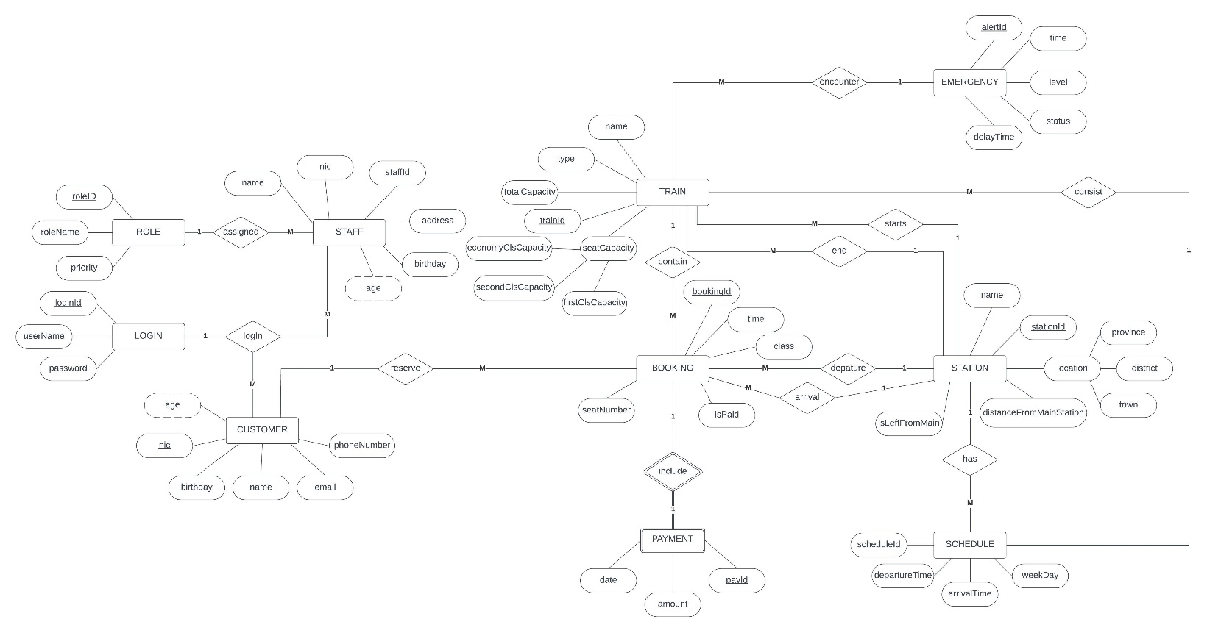

**Assumptions-**

1. Customer needs to log, in order to make a reservation.
2. All rail tracks are interconnected.
3. In order to calculate the fare we used a variable length in KM as “distanceFromMain”.
4. In the database Petta station taken as the main station.
5. To identify whether the station is left or right from the main station a Boolean value was used in STATION entity as “isLeftFromMain”.
6. In BOOKING table “isPaid” value is used to determine whether the payment is processed or not.

# **Relations Explanation**

* CUSTOMER - LOGIN Relation

CUSTOMERs can only make one LOGIN but LOGINs can have many CUSTOMERs.

* STAFF – LOGIN Relation

STAFF can only make one LOGIN but LOGINs can have many STAFFs.

* STAFF – ROLE Relation

One STAFF member can have only one ROLE but one ROLE can be assigned to many STAFF members.

* CUSTOMER – BOOKING Relation

CUSTOMERs can reserve many BOOKINGs but one BOOKING can have only one customer.

* BOOKING – PAYMENT Relation

PAYMENT is necessary to place a BOOKING and a BOOKING can have only one PAYMENT and vice versa.

* BOOKING – TRAIN Relation

One BOOKING can contain only one TRAIN but a TRAIN can contain many BOOKINGs.

* TRAIN – EMERGENCY Relation

TRAINs can encounter only one EMERGENCYs, and an EMERGENCY can occur to many TRAINs.

* TRAIN – STATION Relation

Many TRAINs can start or end from a STATION, but TRAIN can have only one starting STATION and ending STATION.

* STATION – SCHEDULE Relation

One STATION have many SCHEDULEs and a SCHEDULE can have only one STATION.

* TRAIN – SCHEDULE Relation

SCHEDULE consists of many TRAINs, but TRAIN can have only one SCHEDULE.

* BOOKING – STATION Relation

BOOKING can only have one departure STATION and arrival STATION but STATION can have many departures and arrivals.

building diagrams

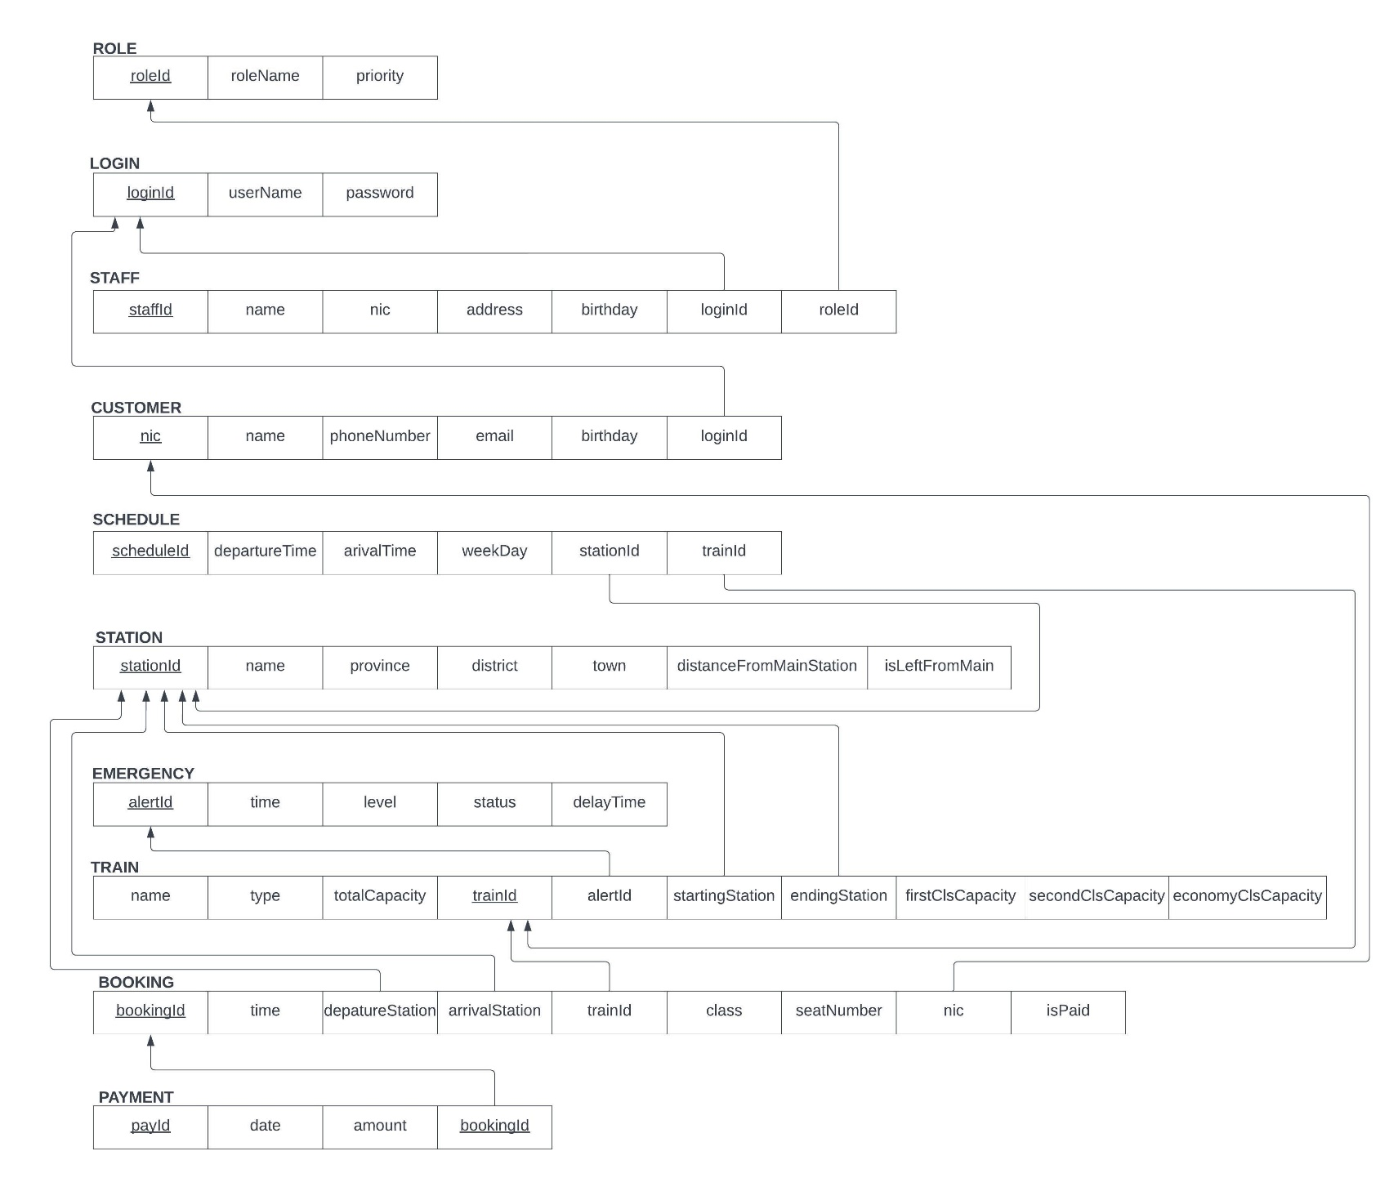Entity Relations to Relational Schemas

Assembling Ideas to a Reality

1. 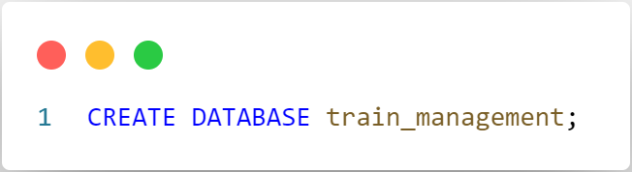CREATION OF THE DATABASE
2. ADDING tables to the database

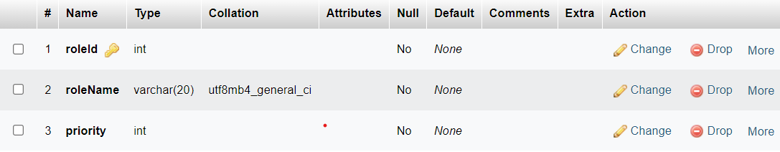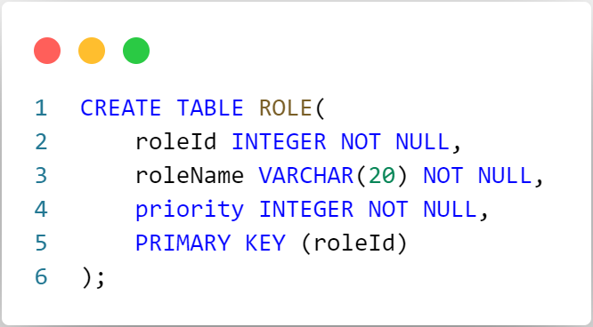**ROLE Table**

**LOGIN Table**

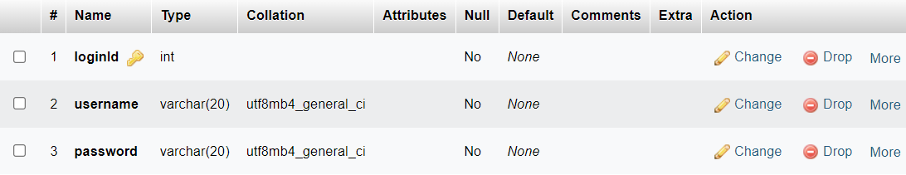

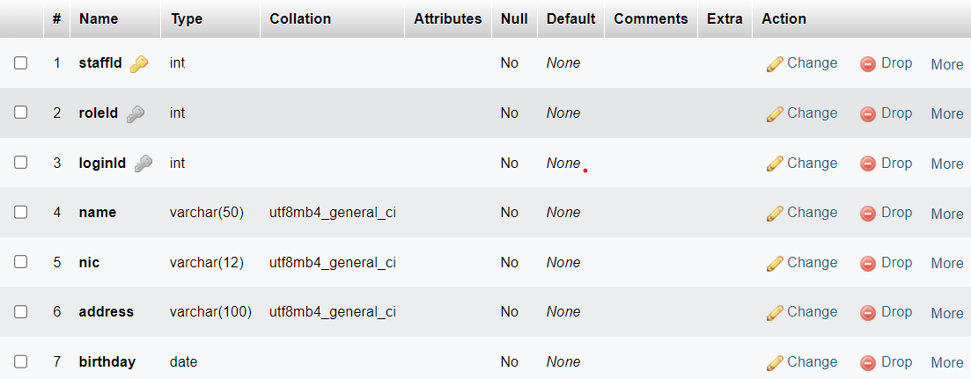**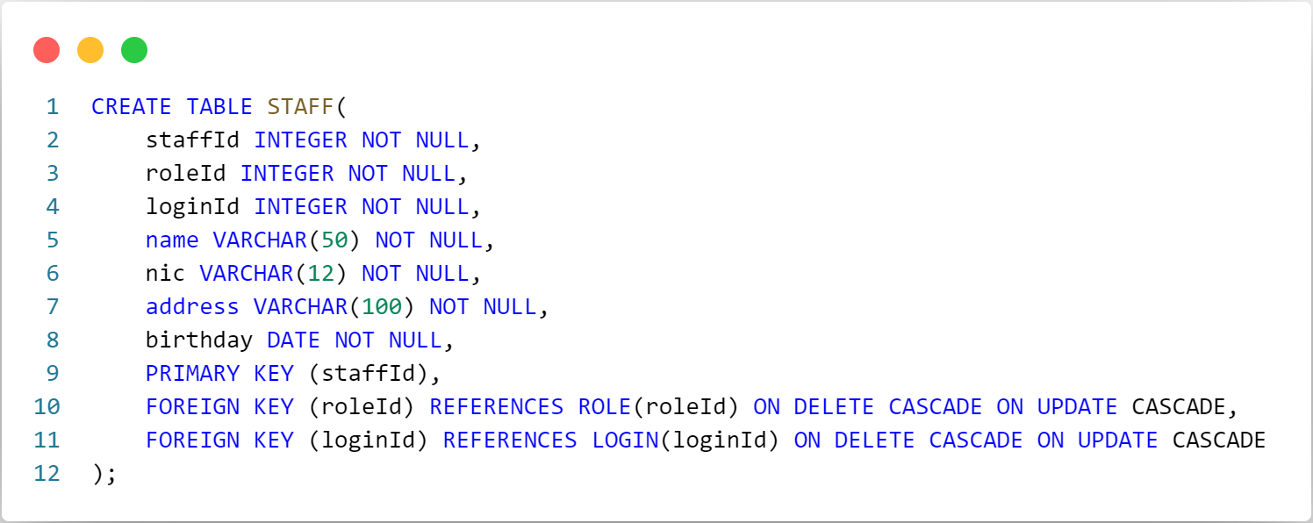STAFF Table**

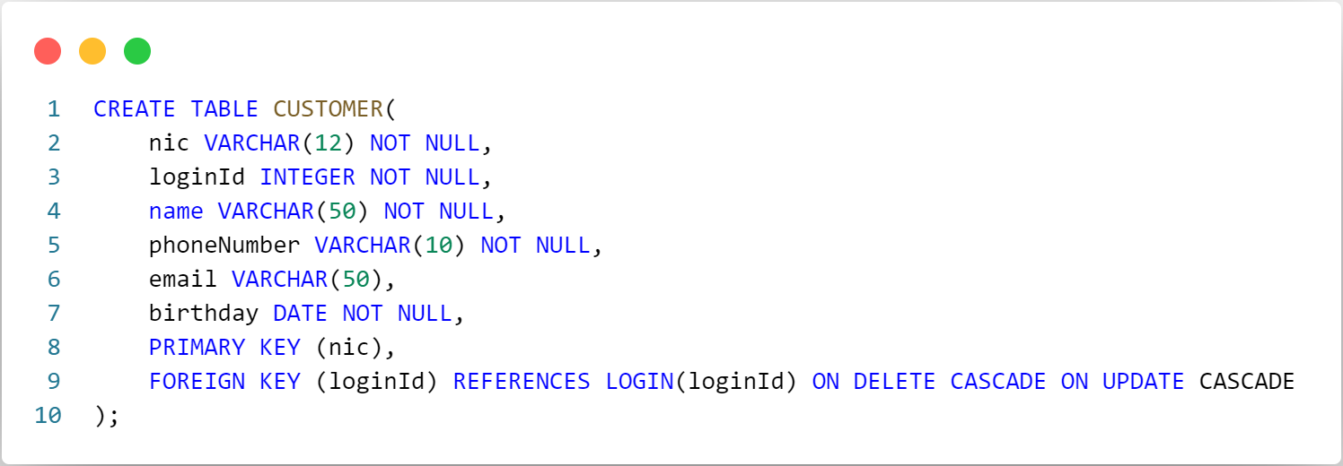**CUSTOMER Table**

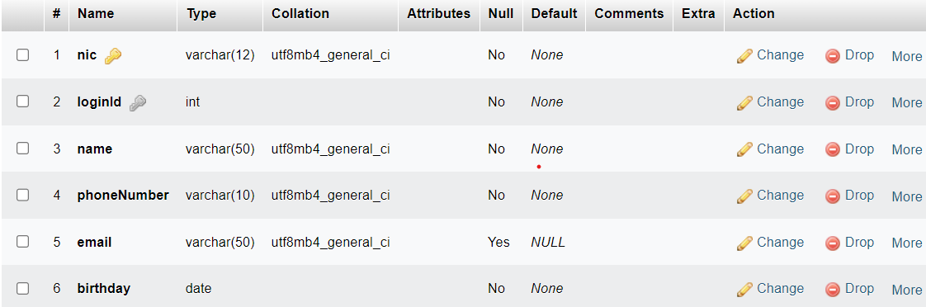

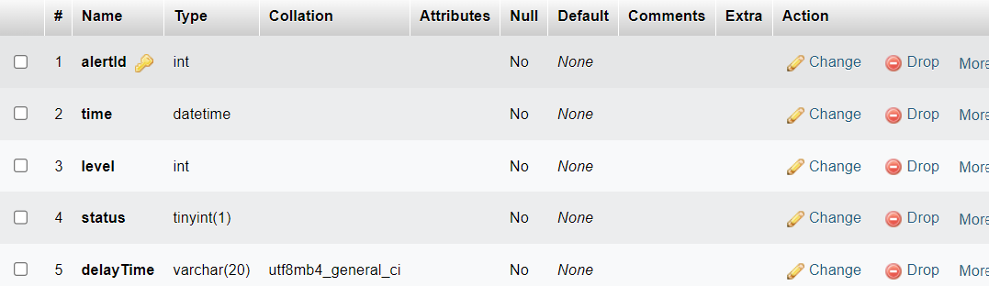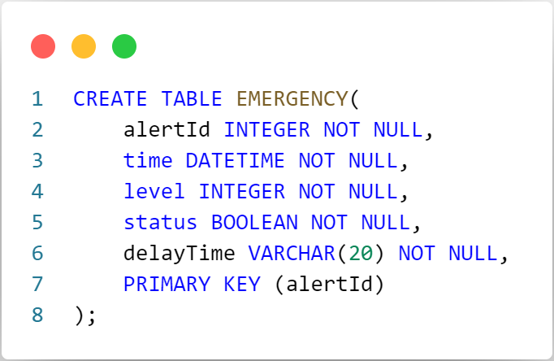**EMERGENCY Table**

**STATION Table**

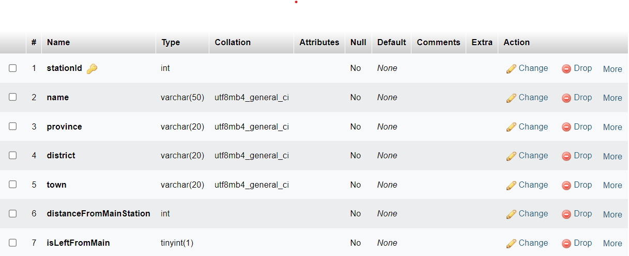

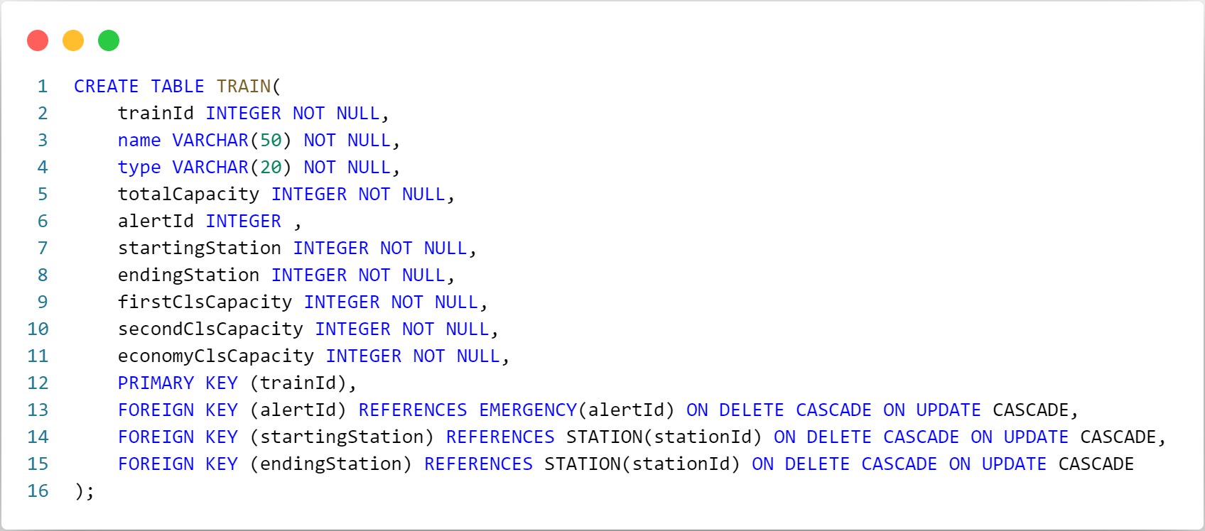**TRAIN Table**

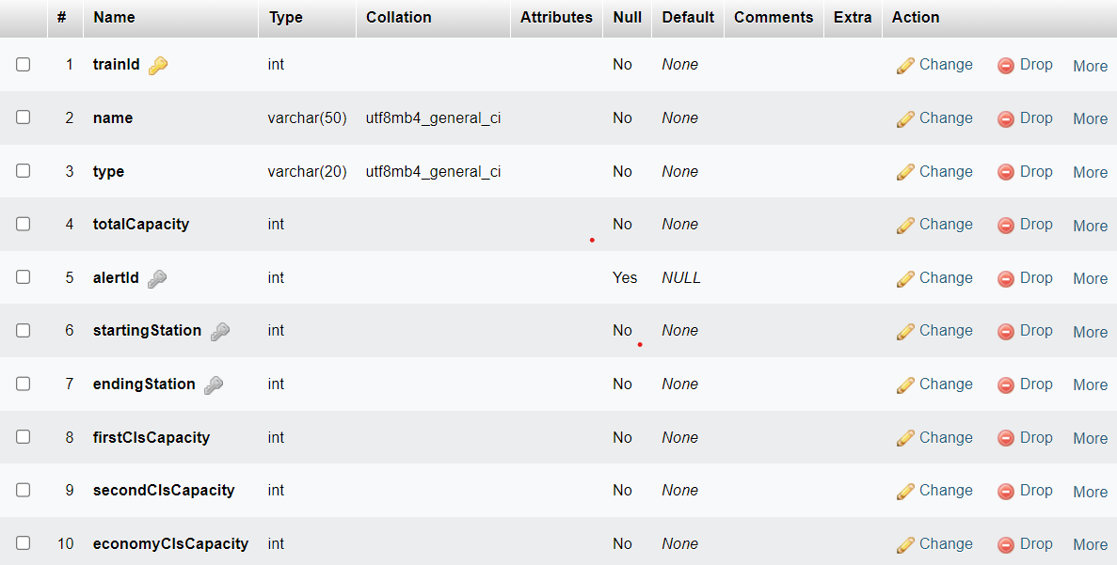

**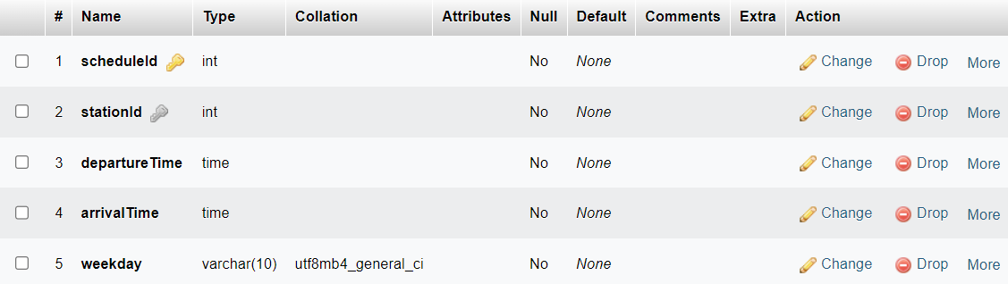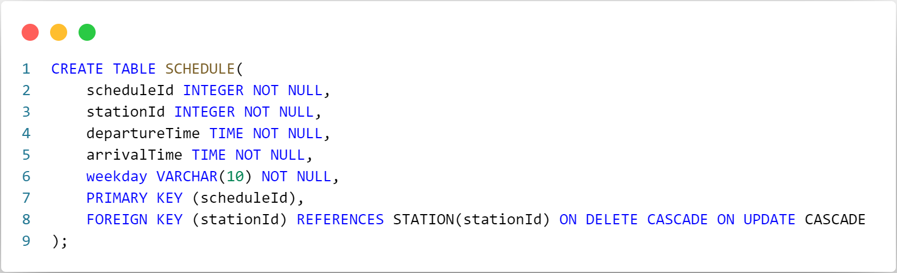SCHEDULE Table**

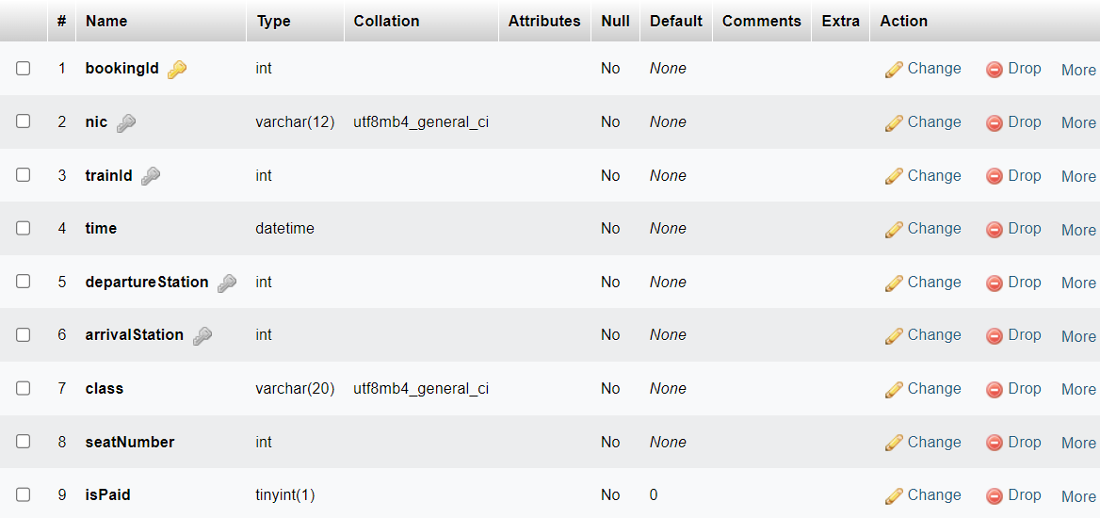**BOOKING Table**

**PAYMENT Table**

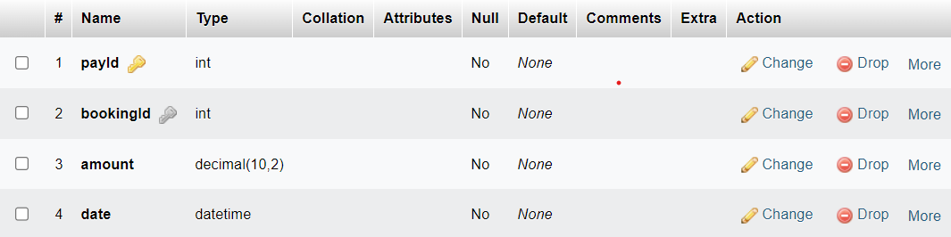

**ALL TABLES**

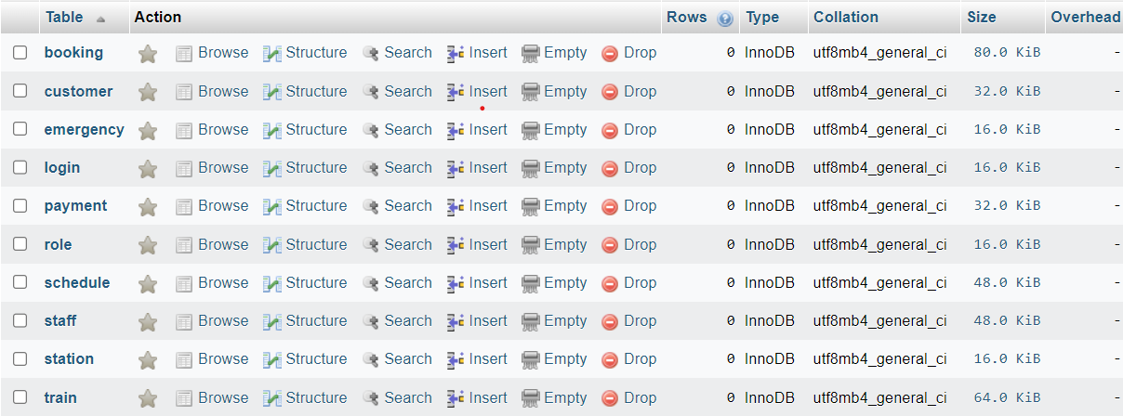

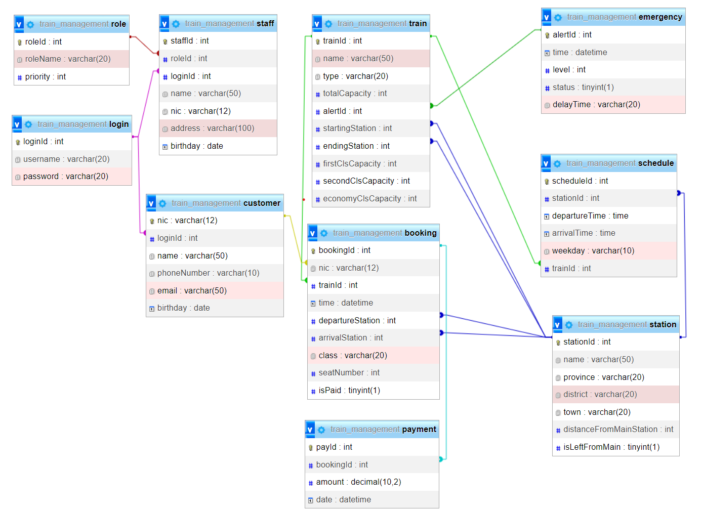**TABLE DESIGN AND CONNECTIONS**

Testing phase

Testing with dummy data and troubleshooting.

**ADDING DUMMY DATA**

* 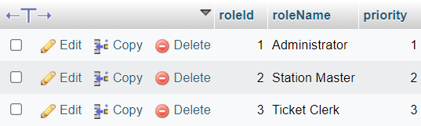A screen shot of a computer code

  Description automatically generatedFor ROLE Table
* A screen shot of a computer code

  Description automatically generatedFor LOGIN Table

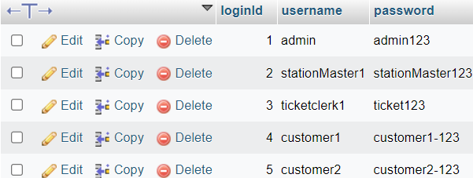

* 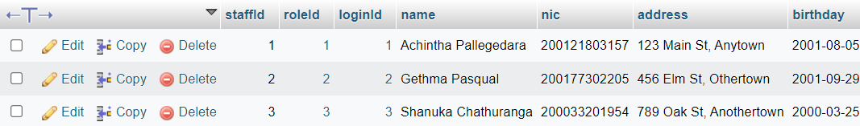A close-up of a computer code

  Description automatically generatedFor STAFF Table
* A screenshot of a computer

  Description automatically generatedA close-up of a number

  Description automatically generatedFor CUSTOMER Table
* 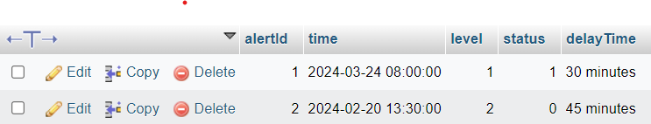A close-up of a computer screen

  Description automatically generatedFor EMERGENCY Table
* 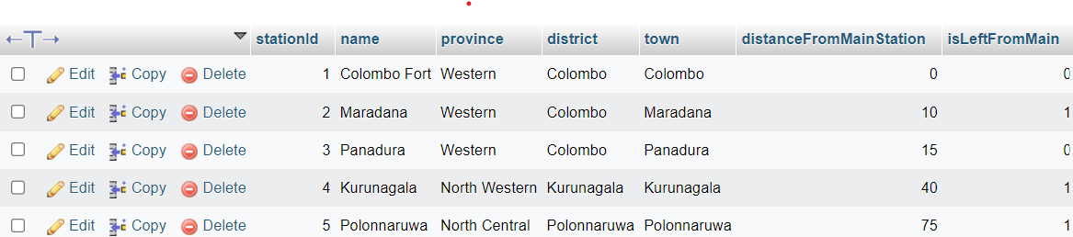A close-up of a white background

  Description automatically generatedFor STATION Table
* A black text on a white background

  Description automatically generatedFor TRAIN Table

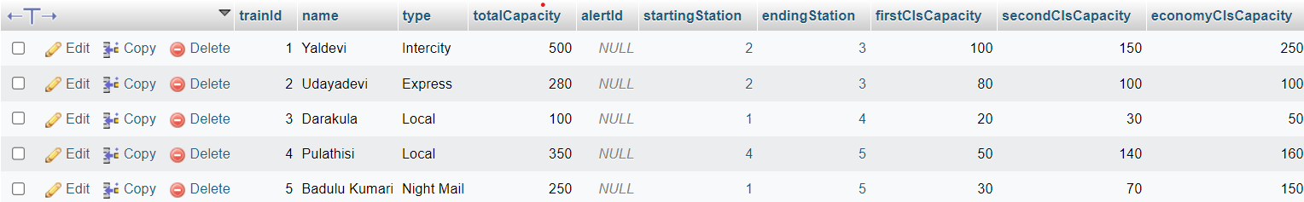

* 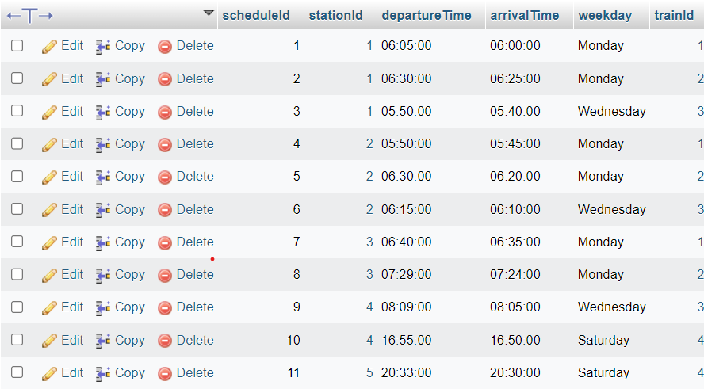A screenshot of a computer program

  Description automatically generatedFor SCHEDULE Table
* A close-up of a checklist

  Description automatically generatedFor BOOKING Table
* 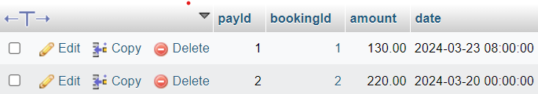**A number and numbers on a white background

  Description automatically generated**For PAYMENT Table

**ALTERING DATA IN THE TABLES USING QUERIES**

* 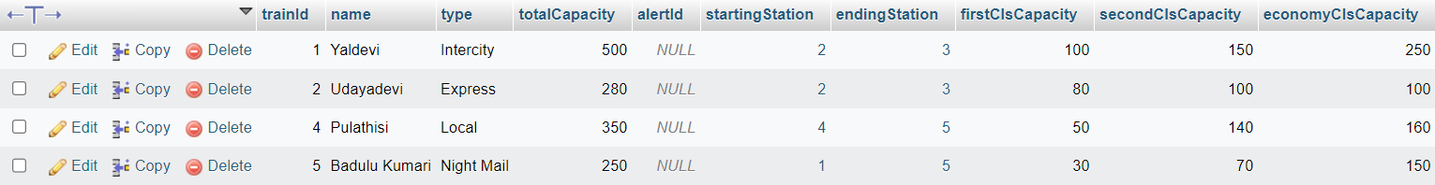A green and black text

  Description automatically generatedDelete a train in the database.

A record was deleted from the TRAIN table, potentially affecting related entries in the SCHEDULE, PAYMENT, and BOOKING tables.

SCHEDULE Table

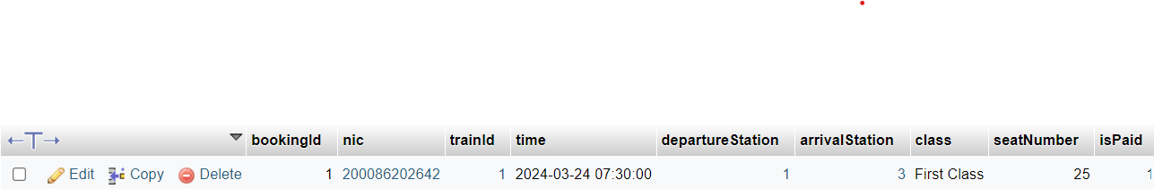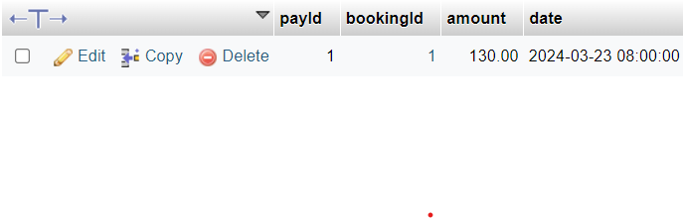PAYMENT Table

BOOKING Table

* 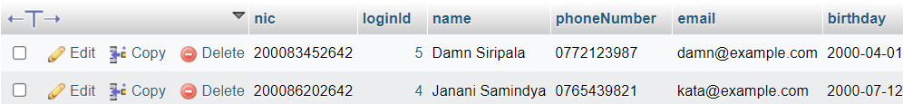Update the phone number of a customer in the database.

* 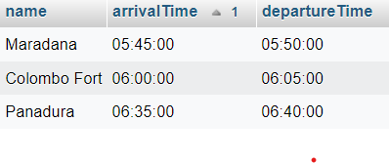A screen shot of a computer code

  Description automatically generatedSelect stations where a particular train stops from the database.

Contributions

What each team member does

1. D.P.G.A.H. Kulathilaka:
   * Contributed to defining the project scope and requirements.
   * Participated in designing the relational schema and ER diagram.
   * Assisted in writing SQL code segments for table creation and data insertion.
   * Collaborated in testing and debugging phases.
2. T.G.D.S. Chathuranga:
   * Contributed to identifying problems in the current booking system.
   * Assisted in exploring relationships and defining assumptions.
   * Participated in designing the core functionalities and system entities.
   * Helped in testing the system and providing feedback for improvements.
3. M.A.S.E.R. Wijerathna:
   * Contributed to outlining the need for a solution and functional requirements.
   * Participated in designing the relational schema and ER diagram.
   * Assisted in writing SQL code segments for table creation and data insertion.
   * Collaborated in the documentation of the project.
4. R.M.D.D. Malinda:
   * Contributed to exploring relationships and defining assumptions.
   * Participated in designing the core functionalities and system entities.
   * Assisted in writing SQL code segments for table creation and data insertion.
   * Collaborated in the testing phase and provided suggestions for improvements.
5. P.T.S. Karunarathna:
   * Contributed to outlining the need for a solution and identifying problems.
   * Participated in designing the core functionalities and system entities.
   * Assisted in writing SQL code segments for table creation and data insertion.
   * Collaborated in the documentation of the project.
6. H.R.S.U. Ranasinghe:
   * Contributed to identifying problems in the current booking system.
   * Assisted in exploring relationships and defining assumptions.
   * Participated in designing the relational schema and ER diagram.
   * Collaborated in the testing phase and provided feedback for improvements.
7. M.A. Sathsarani:
   * Contributed to outlining the need for a solution and functional requirements.
   * Participated in designing the core functionalities and system entities.
   * Assisted in writing SQL code segments for table creation and data insertion.
   * Collaborated in the documentation of the project.
8. G.P.G. Pasqual:
   * Contributed to identifying problems in the current booking system.
   * Assisted in exploring relationships and defining assumptions.
   * Participated in designing the relational schema and ER diagram.
   * Collaborated in the testing phase and provided feedback for improvements.

# -End of the Report-